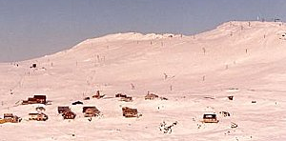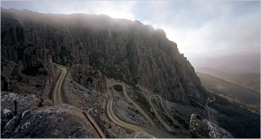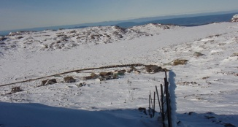
June 2020 | Saturday 27 June | BLC General Meeting : Gunners Arms 630pm
July 2020 | Saturday 4 July | Ben Lomond Snow Sports – Happy Hour
 | Saturday 11 July | Toorbunna - Happy Hour
 | Saturday 18 July | Ski Patrol - Happy Hour
 | Saturday 25 July | Ben Lomond Bender
August 2020 | Saturday 1 August | Bellendena Bash
 | Saturday 8 August | Borrowdale – Happy Hour
 | Saturday 15 August | Ski Races (Alternate date 19 Aug)
 | Saturday 22 August | Birubi St George -Happy Hour
 | August 2018 | NTAC : Quiz Night
September2020 | 5 September 2018
 | 12 September 2018

